**Excel Assignment-9**

1. What are the different margins options and do we adjust the margins of the excel worksheet?

The different margins options available are: Normal, wide, Narrow and yes, we do the adjustments of the excel worksheet according to the data.

1. Set a background for your table created.

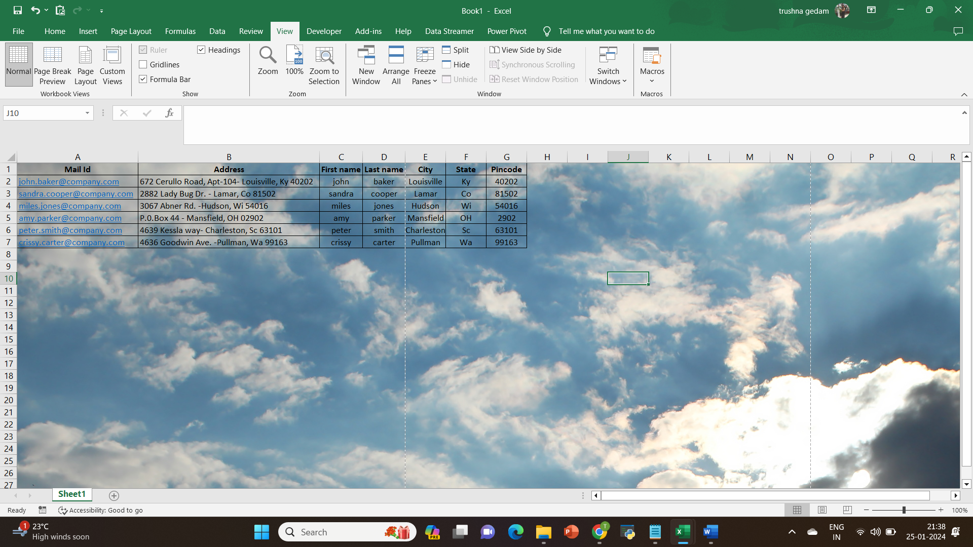

1. What is freeze panes and why do we use freeze panes? Give

Examples?

The Excel Freeze Panes option allows you to lock your columns and/or rows so that when you scroll down or over to view the rest of your sheet, the column and/or row will remain on the screen

1. What are the different features available within the Freeze Panes

Command?

The different features available within the Freeze Panes Command are:

* Freeze Top Row
* Freeze First Column

1. Explain what the different sheet options present in excel are and what

they do?

The different sheet options present in excel are:

* Insert: While working on Excel, we may sometimes need more sheets. For this, we need to go to the Sheet options by right-clicking the worksheet name on the sheet tab, then select Insert from the list. As soon as we click the Insert, the new blank worksheet will appear in the current workbook
* Delete: Excel also allows us to delete the undesired sheets from the workbooks. To delete any desired sheet from the workbook, we must first press the right-click on a specific sheet on the sheet tabs and then select the Delete option from the list of sheet options.
* Rename: To rename the worksheet, we can use the Rename from the sheet options after right-clicking on the desired sheet name on the sheet tab. After that, we need to enter the desired name for the specific worksheet and click the Enter key. The worksheet will be renamed instantly.
* Move or Copy: When we need to duplicate the data from one sheet to another in Excel, we can use the Move and Copy option from the right-click sheet options list. We must first right-click on the sheet that we wish to copy and then select the 'Move and Copy' option.
* View Code: We can launch VB (Visual Basic) Editor by going to any sheet tab, right-clicking ad choosing the option 'View Code
* Protect Sheet: If we protect any desired sheet within the workbook, Excel restricts users from editing or deleting the specific sheet. To protect any particular sheet in an Excel workbook, we need to right-click on the desired sheet and select the 'Protect Sheet' option.
* Tab Color: To change the color of the sheet's tab, we need to select the Tab Color option from the list that we get after right-clicking on the sheet's tab. Next, we must click on the desired color, and it will be immediately applied to the selected sheet tab.
* Hide: To hide a sheet, we need to click on the Hide option from the list of right-click sheet options. As soon as we click the Hide option, the corresponding sheet will no longer be visible on the sheet tabs.
* Select All Sheets: If we want to select all the workbook sheets at once, we can click on the 'Select All Sheets' option from the list. Once all the sheets are selected, we can perform some specific tasks on all the selected sheets at once.